

**Technical Answers for Real World Problems (TARP)**

**PROJECT ON**

**Automatic Room Light Controller with Bidirectional Visitor Counter**

**GROUP MEMBERS:**

**PRAKASH 16MIS1094**

**DAMOTHARAN 16MIS1152**

**NAVEEN 16MIS1073**

**SURYA SS 16MIS1031**

**JEEVAN PRAKASH 16MIS1024**

**Faculty Name: Dr. P.Rukmani**

**Abstract**

This Project ―**”Automatic Room Light Controller with Bidirectional Visitor**

**Counter**” is a reliable circuit that takes over the task of controlling the room lights as well us counting number of persons / visitors in the room very accurately. When somebody enters into the room then the counter is incremented by one and the light in the room will be switched ON and when any one leaves the room then the counter is decremented by one. The light will be only switched OFF until all the persons in the room go out. The total number of persons inside the room is also displayed on the seven segment displays.

**Introduction**

The objective of this project is to make a controller based model to count number of persons visiting particular room and accordingly light up the room. Here we can use sensor and can know present number of persons. In today’s world, there is a continuous need for automatic appliances with the increase in standard of living, there is a sense of urgency for developing circuits that would ease the complexity of life. Also if at all one wants to know the number of people present in room so as not to have congestion. This circuit proves to be helpful. Automatic Room Light Controller with Bidirectional Visitor Counter is a reliable Circuit that takes over the task of counting number of persons/ visitors in the room passing through a single door and also turns ON the room light when there is at-least one person in the room and turns OFF when the room is empty. The total number of persons inside the room is displayed on seven segment display. We can use any other appliance like fan or anything else instead of the light.

**Problem Statement**

This project is not limited to a specific application or a specific operating environment, but it can be easily implemented wherever such an application is needed. This circuit uses a microcontroller which ensures the flexibility of the circuit, due to which this circuit can easily be integrated or assembled with other modules or circuits where ever required. All the components required are readily available in the market and the circuit is easy to build. The significant feature of this project is that it detects the entry and exit of visitors from a single door itself. The problem is, when the first person is entering a room, he should do some work and leave the room as it is without switch off the appliance of the Hostel room, Faculty cabin etc. This is a daunting task. While leaving the room, we cannot guarantee that the last person turns off the lights. To avoid this problem, we have made a circuit which automatically switches ON/OFF the room light depending on the number of people in the room. This circuit keeps track of number of visitors. If the number of visitors is greater than zero, then it turns ON all the lights. Else, it turns OFF all the lights automatically. It does not require any manual intervention.

**Methodology**

This project is divided in four parts: sensors, controller, counter display and gate. The sensor would observe an interruption and provide an input to the controller which would run the counter increment or decrement depending on entering or exiting of the person. And counting is displayed on a 16x2 LCD through the controller.

When any one enters in the room, IR sensor will get interrupted by the object then other sensor will not work because we have added a delay for a while.

**Components**

* Arduino UNO
* Relay (5v)
* Resisters
* IR Sensor module
* 16x2 LCD display
* Bread Board
* Connecting Wires
* Led
* BC547 Transistor

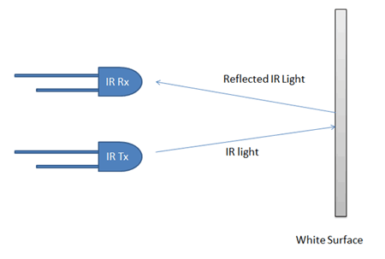

**Working**

**Sensor section:** In this section we have used two IR sensor modules which contain IR diodes, potentiometer, Comparator (Op-Amp) and LED’s. Potentiometer is used for setting reference voltage at comparator’s one terminal and IR sensors sense the object or person and provide a change in voltage at comparator’s second terminal. Then comparator compares both voltages and generates a digital signal at output. Here in this circuit we have used two comparators for two sensors. LM358 is used as comparator. LM358 has inbuilt two low noise Op-amp.

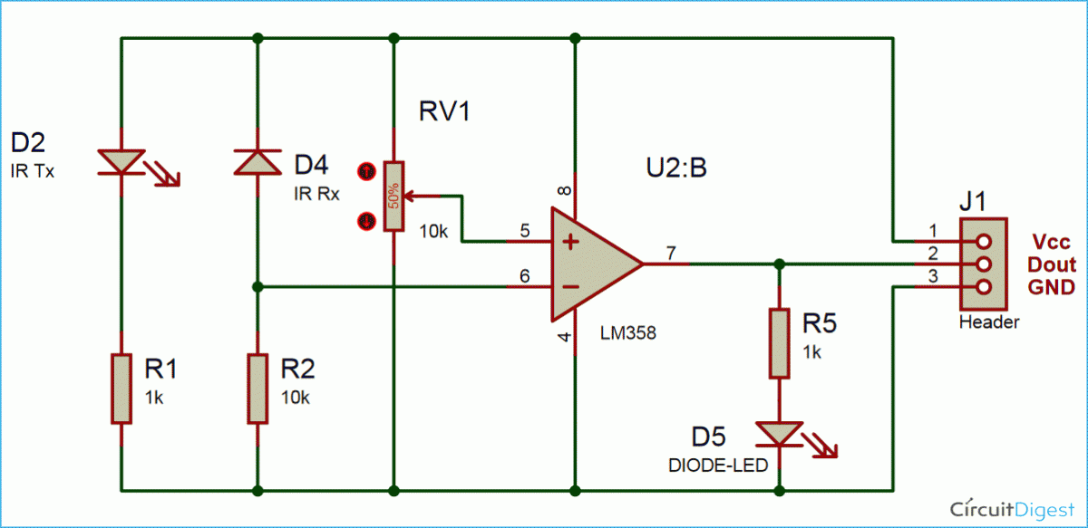

**Control Section:** Arduino UNO is used for controlling whole the process of this visitor counter project. The outputs of comparators are connected to digital pin number 14 and 19 of arduino. Arduino read these signals and send commands to relay driver circuit to drive the relay for light bulb controlling. If you find any difficulty in working with relay, check out this tutorial on [arduino relay control](https://circuitdigest.com/microcontroller-projects/arduino-relay-control) to learn more about operating relay with Arduino.

**Display section:**  Display section contains a 16x2 LCD. This section will display the counted number of people and light status when no one will in the room.

**Relay Driver section**: Relay driver section consist a BC547 transistor and a 5 volt relay for controlling the light bulb. Transistor is used to drive the relay because arduino does not supply enough voltage and current to drive relay. So we added a relay driver circuit to get enough voltage and current for relay. Arduino sends commands to this relay driver transistor and then light bulb will turn on/off accordingly.

### ****Visitor Counter Circuit Diagram****

The outputs of IR Sensor Modules are directly connected to arduino digital pin number 14(A0) and 19(A5). And Relay driver transistor at digital pin 2. LCD is connected in 4 bit mode. RS and EN pin of LCD is directly connected at 13 and 12. Data pin of LCD D4-D7 is also directly connected to arduino at D11-D8 respectively. Rest of connections are shown in the below circuit diagram.

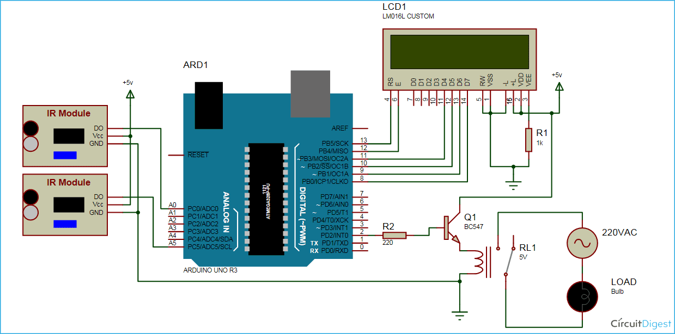

**Conclusion**

This project deals with the usage of the energy in this competitive world of electricity. This project is efficient enough to let someone know about the accuracy of the person entered and have taken the exit from the room. This project saves more electric power than it seems and also collaborates the knowledge of electric and digital study. One can be knowledgeable about two different study at the same time with this project. It not only teaches us about the functioning of the but also teaches us how we can preserve electricity even in the electricity based project.

**Sample Code :**

#include<LiquidCrystal.h>

LiquidCrystal lcd(13,12,11,10,9,8);

#define in 14

#define out 19

#define relay 2

//#define CONTRAST_PIN 3

//#define CONTRAST_VALUE

int count=0;

void IN()

{

count++;

lcd.clear();

lcd.print("Person In Room:");

Serial.print("Person In Room:");

lcd.setCursor(0,1);

lcd.print(count);

Serial.println(count);

delay(2000);

}

void OUT()

{

if(count<=0){

count=0;

}

else{

count--;

}

lcd.clear();

lcd.print("Person In Room:");

Serial.print("Person In Room:");

lcd.setCursor(0,1);

lcd.print(count);

Serial.println(count);

delay(2000);

}

void setup()

{

Serial.begin(9600);

lcd.begin(16,2);

digitalWrite(relay,200);

lcd.print("Visitor Counter");

Serial.print("Visitor Counter");

delay(2000);

pinMode(in, INPUT);

pinMode(out, INPUT);

pinMode(relay, OUTPUT);

lcd.clear();

lcd.print("Person In Room:");

Serial.print("Person In Room:");

lcd.setCursor(0,1);

lcd.print(count);

Serial.println(count);

}

void loop()

{

if(digitalRead(in) && !digitalRead(out))

{

IN();

}

if(digitalRead(out) && !digitalRead(in))

{

OUT();

}

if(count<=0)

{

lcd.clear();

digitalWrite(relay, LOW);

lcd.clear();

lcd.print("Nobody In Room");

Serial.print("Nobody In Room");

lcd.setCursor(0,1);

lcd.print("Light Is Off");

Serial.println("Light Is Off");

delay(200);

}

else

digitalWrite(relay, HIGH);

}

**Output Screenshots:**



